Vision-Based Price Movement Classification from Candlestick Chart Images

Final Project 2 – Milestone 2
Zicheng (Chance) Xu
DSC 680: Applied Data Science
Bellevue University
Professor: Amirfarrokh Iranitalab
Date: February 8, 2026

Business Problem
Traders often make quick decisions by looking at charts, but those decisions are subjective and inconsistent. In this project, I’ll try to answer a practical question: can a machine learning model learn useful information directly from a candlestick chart image and use it to predict short‑term price movement? A repeatable model that reads charts could help standardize analysis workflows, support research, and provide a structured baseline for comparing chart‑based signals versus traditional numeric indicators. For this project, my goal is not to build a profitable trading system. Instead, I’ll focus on building a complete, reproducible pipeline (data → labels → images → model training → evaluation) and measuring whether the signal is strong enough to generalize out‑of‑sample. In addition, I will include numerical indicators and test whether combining them with the image-based model improves overall performance.

Background/History
Candlestick charts compress multiple pieces of information (open, high, low, close) into a single visual pattern (Figure 1). Many common chart concepts—trend, volatility, momentum, and “support/resistance”—are visual interpretations of this information. Recent deep learning models are good at finding patterns in images, which raises the question of whether a chart image contains predictive signals that a neural network can learn. At the same time, financial markets are noisy and non‑stationary, so even a well‑trained model can fail when market conditions change. Because of this, I’ll use time‑based splits and keep the evaluation strictly out‑of‑sample to reduce look‑ahead bias and to get a more realistic picture of performance. Because this project is designed for research rather than professional trading deployment, I’ll use daily price data, as higher-frequency data would require much larger datasets and more complex algorithms that are beyond the scope of this study.

Data Explanation (Data Prep/Data Dictionary/etc.)
I used daily OHLCV (open, high, low, close, volume) data for four liquid U.S. tickers: SPY, AAPL, MSFT, and NVDA. SPY is an exchange-traded fund that tracks the S&P 500 by holding shares of all 500 companies in the index. AAPL, MSFT, and NVDA represent Apple, Microsoft, and Nvidia, three widely traded U.S. technology companies. Data was downloaded from Stooq (CSV endpoint) and cached locally for reproducibility. The study period spans January 2015 through December 2025, producing 11,064 daily rows before labeling and feature engineering. After labeling and removing rows without sufficient future horizon, the dataset contained 10,748 image‑aligned samples across the four tickers.
Data preparation steps included standardizing column names, sorting by date, filtering to the configured date range, and dropping rows with missing close prices. I engineered two kinds of model inputs: (1) candlestick chart images created from rolling lookback windows (explained later), and (2) a small set of numeric indicators for the multi‑modal experiments. All scaling for numeric features was fit on the training split only, then applied to validation and test splits to avoid leakage.
Data dictionary (core fields) includes: date (trading day), open/high/low/close (daily prices), volume (shares traded), ticker (asset identifier). Derived fields: label (Down/Hold/Up from triple‑barrier, explained later), image_path (relative path to chart image), and indicator columns (e.g., RSI, MACD, Bollinger measures) for multi‑modal runs.

Methods
I framed the task as a 3‑class classification problem using a triple‑barrier labeling method. For each day t, I treat the close price as the entry price and look forward 20 trading days. If price reaches +5% first, the label is Up; if price reaches −5% first, the label is Down; if neither barrier is hit by the end of the horizon, the label is Hold. This labeling approach maps naturally to a simple “up / down / no clear move” outcome and avoids relying on a single end‑of‑window return threshold. I consider a 5% threshold to be reasonable for a 20-day performance window, given the relatively low volatility of the four selected tickers.
For the image input, I generated one PNG image per labeled date using a fixed lookback window of prior trading days (for example, 60 days) ending on the prediction date. Each image was rendered as a simplified candlestick chart with a volume panel, using consistent formatting and a fixed resolution (224×224) so the CNN could learn from comparable inputs. Candles (and volume bars) were color-coded using standard charting conventions (green when close ≥ open, red otherwise), axes and labels were removed to avoid text leakage, and images were saved with a consistent naming scheme (ticker/date) so they could be joined back to labels and features through image_path, and the model could map every image saved to my working directory with the ticker and date, later to be merged with numerical features (Figure 2).
I trained three related models: (1) a vision-only baseline using a ResNet18 model fine-tuned for three classes, (2) a multi-modal fusion model that combines ResNet18 image features with a small MLP built on numerical indicators, and (3) an alternative multi-modal version using a different set of indicators (MACD, RSI, and Bollinger Bands), motivated by the limited performance improvement observed in model (2) compared to model (1). I used a time‑based split within each ticker (70% train, 15% validation, 15% test) to prevent information from the future leaking into training. Performance was measured using accuracy and macro F1 (which treats all classes equally), along with confusion matrices to understand which classes are most frequently confused.
For the multi-modal experiments, I derived numeric indicators directly from the daily close (and, in earlier runs, volume) series for each ticker, calculated in time order so that each day’s indicator values only used information available up to that day. Before computing indicators, I sorted each ticker’s data by date and treated missing early values from rolling windows as expected (for example, Bollinger Bands need a full 20-day window). For RSI(14), I computed daily price changes from the close series, separated them into gains and losses, and then applied Wilder-style exponential smoothing over a 14-day window to produce a bounded momentum score from 0 to 100. For MACD (12, 26, 9), I computed two exponential moving averages of the close price (12-day and 26-day), took their difference as the MACD line, computed a 9-day exponential moving average of the MACD line as the signal line, and used the difference between MACD and signal as the MACD histogram to represent momentum shifts. For Bollinger Bands (20, 2σ), I computed a 20-day simple moving average of the close (middle band) and the 20-day rolling standard deviation, then formed the upper and lower bands as the middle band plus or minus two standard deviations. Instead of feeding the raw band levels into the model, I used two normalized features: percent_b, which measures where the close sits within the band range (roughly 0 to 1 in typical cases), and bandwidth, which measures band width relative to the moving average as a proxy for volatility. Finally, I standardized all numeric indicators using mean and standard deviation computed from the training split only, then applied the same scaling to validation and test splits to prevent data leakage (Figure 3).

Analysis
The triple‑barrier labels were reasonably balanced overall: Up was the majority class (~44%), followed by Down (~31%) and Hold (~25%). However, label mix varied by ticker: SPY had many Hold outcomes (consistent with lower volatility relative to a fixed ±5% barrier), while NVDA had very few Hold outcomes (consistent with relatively higher volatility among the four tickers). This variation suggests that a single fixed barrier may behave differently across assets, which can affect learnability (Figure 4).
The vision‑only ResNet18 model showed very high training accuracy (near 0.99) but much lower validation accuracy (best around 0.48), indicating overfitting and limited generalization. On the test set, the vision‑only run only achieved 0.452 accuracy and 0.447 macro F1. The confusion matrix showed the model often confused Down and Up, and Down had the lowest recall.
To test whether additional context could improve performance, I evaluated two multi-modal fusion variants that combined the candlestick image with numeric indicators. The first multi-modal model used a small set of basic features derived from price and volume (momentum/trend and volume-based measures), but it did not produce a meaningful improvement over the vision-only baseline. Because those indicators did not add clear predictive value, I ran a second multi-modal experiment using three widely used technical indicator families—MACD, RSI, and Bollinger Bands—to see whether more standard momentum and volatility descriptors would improve generalization.
Using MACD, RSI, and Bollinger measures produced a best validation accuracy of ~ 0.49 and test performance of 0.459 accuracy and 0.455 macro F1. This is again a negligible improvement over the majority‑class baseline (~0.439), and thus it does not represent a large or consistent gain over the vision‑only approach. Down remains the hardest class; many true Down cases are still predicted as Up, which is visible in the confusion matrix (Figure 5).
Overall, the results suggest that—under this labeling setup and with these four tickers—chart images alone do not provide a strong enough signal for robust direction classification, and adding standard indicators only improves performance marginally.

Conclusion
In this project, I built a complete end‑to‑end pipeline for chart‑based prediction: data collection, triple‑barrier labeling, candlestick image generation, time‑based splits, and model training/evaluation. The best models achieved test accuracy in the mid‑0.45 range with macro F1 around 0.45, which is only modestly above a simple majority baseline. The main error pattern is confusion between Down and Up, suggesting that either the image representation, the labeling method, or the model architecture needs refinement for stronger performance.

Assumptions
I assume that daily OHLCV data from Stooq is sufficiently accurate for research purposes and that the 60‑day lookback window represents the information a typical chart reader would use. I also assume that the triple‑barrier parameters (20‑day horizon and ±5% barriers) produce labels that reflect meaningful short‑term outcomes across the selected assets. Finally, I assume that a time‑based split per ticker is an appropriate way to approximate real‑world deployment where the model is trained on past data and applied to future periods.

Limitations
This draft has several limitations. First, the study uses only four tickers, which limits how well results generalize to other assets or market regimes. Second, fixed barriers (±5%) do not account for different volatility levels across assets, which likely contributes to very different Hold rates (for example, SPY vs NVDA). Third, the vision model uses a general-purpose ResNet18 architecture; specialized architectures or additional regularization may very likely be needed to reduce overfitting. Finally, the evaluation focuses on classification metrics; I do not yet test calibration, stability across time, or the economic meaning of errors. In my view, the biggest limitation of this approach is that financial markets can react to news in real time, often within minutes or even seconds, while my model only looks at daily price changes. For example, news such as the nomination of a new Federal Reserve chair in late January 2026 triggered significant market volatility, particularly in gold and silver during overnight trading. In contrast, my model is designed to capture broader trends over a 20-day window rather than short-term reactions.

Challenges
The main challenges were building a reproducible workflow that aligns images, labels, and numeric features without leakage. Generating and storing thousands of chart images also required careful folder organization and consistent rendering settings. Another challenge is that training on financial data is sensitive to time splits and regime changes; models can look strong in-sample but weaken out-of-sample, which is what I observed in the validation/test results.

Future Uses/Additional Applications
Even without much predictive performance, this pipeline can still be useful as a research framework. Future work could extend to more tickers, volatility-scaled barriers, and alternative labeling schemes (e.g., direction of next-day return, or regression on future returns), or even integrated to track macro/micro economic/financial/corporate/etc. events in real time and working with AI. On the modeling side, possible extensions include data augmentation for charts, stronger regularization, early stopping, and architectures designed for time-series images. This work can also be adapted as an educational example of how to turn raw time-series data into image-based model inputs and evaluate them correctly with time-based splits.

Recommendations
My main recommendation is to adjust the labeling scheme to better reflect asset-specific volatility—such as setting barriers based on recent realized volatility—so that the Hold rate is not extremely different across tickers. I also recommend expanding the asset universe (more tickers and different sectors) to reduce overfitting to a small set of names. From a modeling perspective, adding stronger regularization (weight decay tuning, dropout, early stopping) and exploring a smaller learning rate schedule may improve generalization. Finally, I recommend reporting additional diagnostics (per‑ticker metrics and time‑slice performance) to understand when and where the model fails.

Implementation Plan
A realistic implementation plan would start with data automation and monitoring: schedule daily data pulls, validate completeness, and regenerate indicators and images consistently. Next, retrain the model on a rolling basis (for example, quarterly) using only past data, and track out-of-sample metrics to detect drift. Because this approach is still experimental, the model outputs should be treated as research signals rather than automated decisions. In the near term, the deliverable is a reproducible notebook and a documented pipeline that can be rerun end‑to‑end to produce the same datasets, figures, and evaluation outputs.

Ethical Assessment
This project does not raise meaningful privacy concerns because it uses only publicly available market price data. The main ethical issue is the risk of overstating what the model can do. In its current form, the model performs poorly and does not provide reliable predictions. Because of that, the results should be treated as a research exercise and a learning outcome, not as evidence that the approach is effective or ready for real-world use. To reduce the chance of misunderstanding, I present the results plainly and emphasize the negative findings, including comparisons to simple baselines and a clear discussion of limitations. The goal is to be transparent that the model’s predictive value is low, and that it should not be used to guide trading decisions. A secondary consideration is resource usage. Training deep learning models consumes computing resources, so I keep the model architecture lightweight and limit training runs to what is necessary to complete the analysis responsibly.

10 Audience Questions/Answers for Milestone 3
- Why did you choose the triple-barrier labeling method instead of a simple up/down label?
A simple up/down label only checks whether the price is higher or lower after a fixed period, but it ignores how price moved in between. Triple-barrier labeling is closer to trading reality: it distinguishes between (1) hitting an upside move, (2) hitting a downside move, or (3) doing neither within the horizon (“Hold”). That reduces “label noise” where prices briefly move strongly one way, then reverse by the end of the horizon. It also gives a cleaner definition of outcomes that better matches risk-managed decision-making.
- Why was a 20-day horizon selected for labeling instead of a shorter time frame?
Twenty trading days is roughly one month, which is long enough for a meaningful trend to develop and for a ±5% move to occur sometimes, but not so long that the label becomes disconnected from what the chart window represents. Shorter horizons (like 1–5 days) are dominated by noise and micro-events, which makes labels unstable and harder for a model to learn from images.
- Why was a ±5% barrier used for labeling, given the volatility characteristics of the selected tickers?
±5% is a practical, interpretable move size: big enough to avoid labeling tiny day-to-day fluctuations as “Up” or “Down,” but small enough to happen within a 20-day window often enough to produce signal. That said, the project results also show a limitation: the same fixed barrier behaves very differently across assets with different volatility. This is one reason future work could use volatility-adjusted (e.g., ATR- or σ-scaled) barriers.
- Why does SPY produce a much larger number of Hold labels compared to NVDA, and how does this affect class balance?
SPY is typically less volatile than NVDA. With the same ±5% barrier and 20-day horizon, SPY often doesn’t reach either barrier, so it lands in “Hold” more frequently. NVDA, being more volatile, hits ±5% more often, so it produces fewer Hold outcomes. This makes class balance vary by ticker and can cause the model to learn “ticker-specific volatility behavior” rather than generalizable visual patterns.
- How does class imbalance (especially the Hold class) impact model performance and evaluation?
Imbalance can bias the model toward predicting the majority class more often, which can inflate raw accuracy while still performing poorly on minority classes. That’s why we emphasize metrics like macro F1 (which weights classes more equally) and examine the confusion matrix. Even if overall accuracy looks acceptable, low recall for “Down” or poor separation between “Up” and “Down” indicates the model isn’t reliably learning actionable signals.
- How does the vision-only model compare to the multi-modal fusion models in terms of performance?
The vision-only ResNet18 showed strong training accuracy but much weaker validation/test performance, indicating overfitting. The multi-modal fusion models (adding indicators like MACD/RSI/Bollinger) produced only a small improvement at best—not a meaningful performance jump. Overall, the comparison suggests that the added numeric features did not unlock a stronger, more generalizable signal under the current design.
- Why did adding numerical indicators fail to meaningfully improve model performance?
There are several likely reasons. First, indicators may be redundant with what the candlestick/volume image already implies (trend + momentum cues). Second, simple fusion may be too weak: concatenating a few numbers to an image embedding might not be enough to model complex interactions. Third, signal-to-noise is still low: even good indicators can fail if labels are noisy or if the task is near-random at this horizon/barrier setting. Also, asset heterogeneity (different volatility regimes) can swamp any incremental benefit from indicators.
In short, the issue may be more about the labeling/task design and regime variation than the absence of indicators.
- Which prediction errors occur most frequently, and what do they tell us about the model’s limitations?
The most common error pattern is confusing “Up” and “Down,” and “Down” tends to have the lowest recall. This suggests the model struggles to consistently detect bearish setups from images alone, or that the visual differences between pre-up and pre-down patterns are not stable in this dataset. It also implies the model may be picking up broad “trend strength” signals but not reliable directionality under noisy market conditions.
- Why is this model better suited for identifying medium-term trends rather than reacting to short-term market events?
Candlestick images summarize recent price structure—trend, volatility, and momentum—but they do not directly encode sudden news catalysts, earnings surprises, or macro events. Short-term moves are often driven by information that is not present in the chart image. With a 60-day lookback and 20-day labeling horizon, the model is naturally aligned with medium-term pattern learning, not instant reaction to event-driven price jumps.
- What is the main takeaway from the negative or weak results of this project?
The key takeaway is that candlestick images alone (and even with simple indicator fusion) did not produce strong, generalizable predictive power for this labeling setup. That result is still valuable: it shows the limits of a naive “vision-only chart prediction” approach and points to better next steps—such as volatility-adjusted barriers, stronger multi-modal fusion designs, better regularization, regime-aware modeling, and richer features beyond chart images. Negative results help avoid false confidence and guide more realistic model design for financial forecasting.

Illustrations

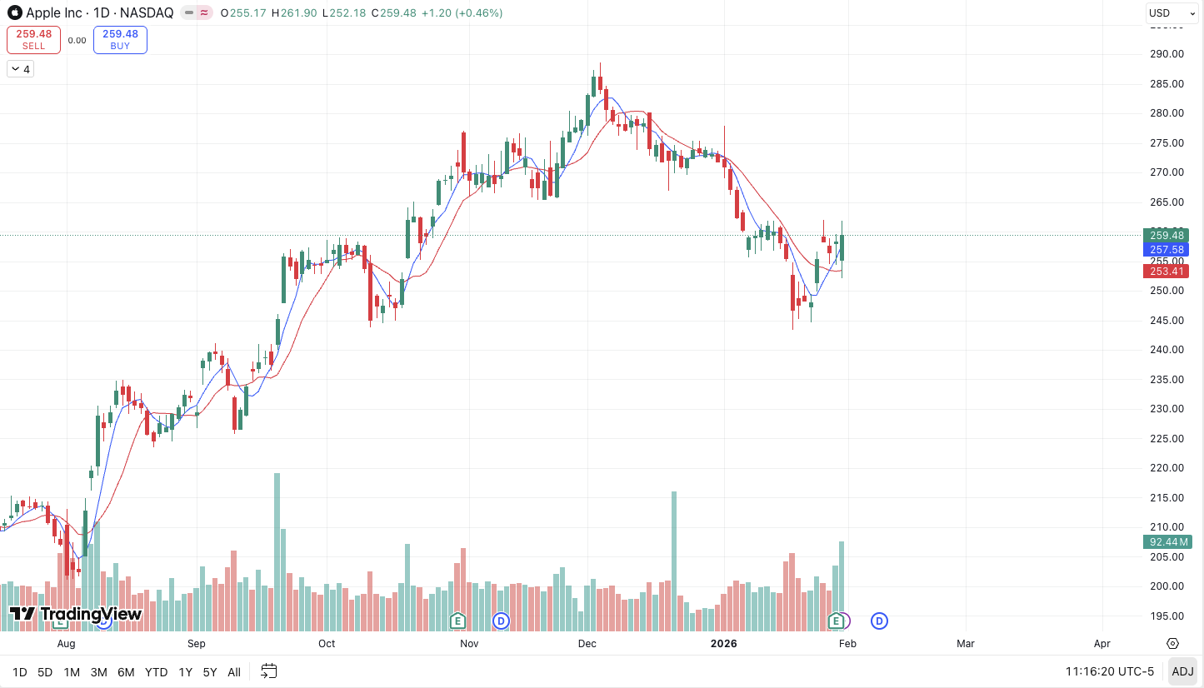
Figure 1. Example candlestick chart (Apple Stock as of February 1, 2026; Source: TradingView.com).

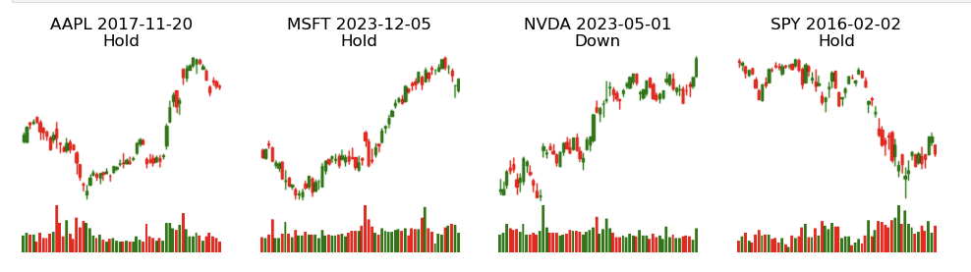
Figure 2. Example candlestick chart images used as model inputs (224×224 with volume panel).

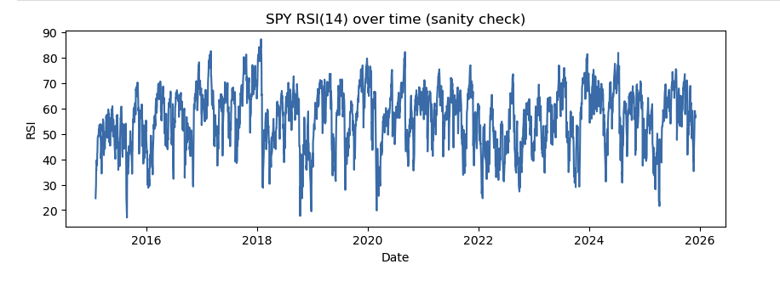
Figure 3. RSI(14) over time for SPY (sanity check for indicator calculation).

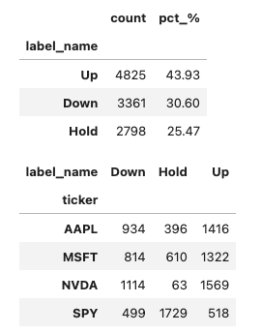
Figure 4. Triple-barrier labels class balance.

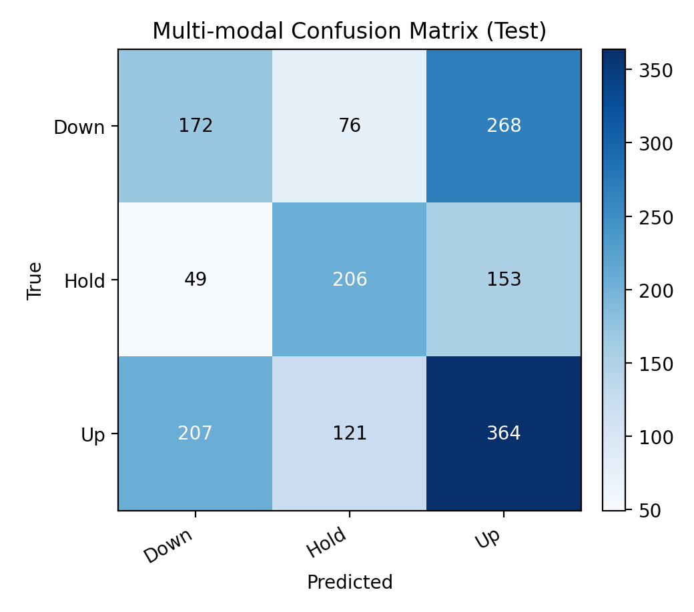
Figure 5. Multi‑modal model (MACD+RSI+Bollinger) confusion matrix on the test split.

Appendix: Supporting Documentation

Key configuration used in this milestone: tickers={SPY, AAPL, MSFT, NVDA}; date range=2015–2025; lookback window=60 trading days; image size=224×224; triple‑barrier horizon=20 trading days; profit‑take=+5%; stop‑loss=−5%; time split=70% train / 15% validation / 15% test per ticker.
Model summary: ResNet18 backbone (ImageNet weights) fine‑tuned for 3‑class classification; multi‑modal fusion adds an MLP on numeric indicators and concatenates with the ResNet feature vector before the final classifier.
Outputs generated by the notebook include cached OHLCV CSVs, image files under artifacts_project2/images/<TICKER>/, a samples index table linking (ticker, date) to image path and features, and evaluation outputs including classification reports and confusion matrices.

References

Bollinger, J. (2001). Bollinger on Bollinger Bands. McGraw-Hill.
Lopez de Prado, M. (2018). Advances in Financial Machine Learning. Wiley.
PyTorch. (2025). PyTorch documentation. https://pytorch.org/
scikit-learn developers. (2025). scikit-learn: Machine Learning in Python. https://scikit-learn.org/
Stooq. (2025). Stooq historical data. https://stooq.com/
Wilder, J. W. (1978). New Concepts in Technical Trading Systems. Trend Research.

